**Coding challenge**

**Python**

**Name: Rohan Vinayak Chaudhari**

**Batch: Data Engineering 1**

**Question2:** Execute with one example Lambda Functions in Python&Read JSON Strings to Python dicts

**1)Lambda Function:**

**In this function we are getting a square a input int.**

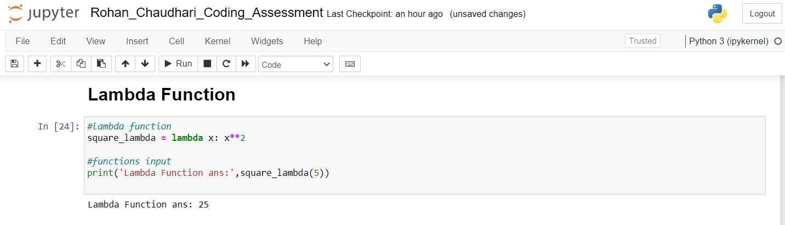

**2) Read JSON Strings to Python Dicts:**

**Created a string and load it to json**

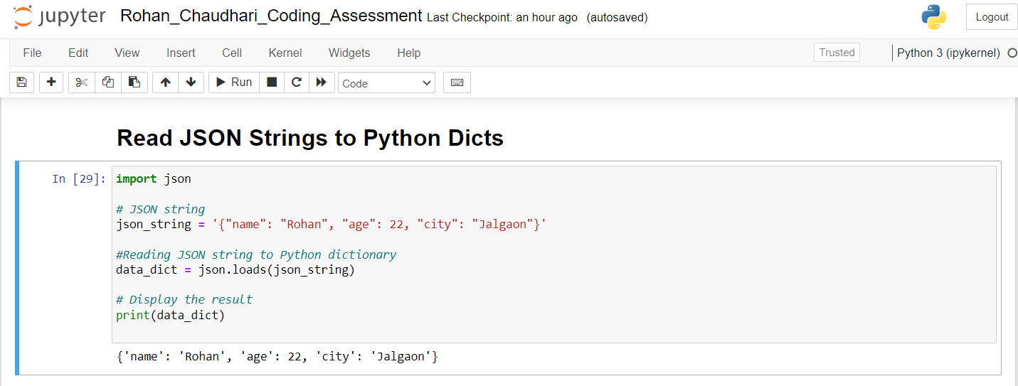

**3) Reading JSON data from file:**

**Read data from a already existing json file**

